Project Design Phase-II
Data Flow Diagram & User Stories
Date
Team ID | SWTID-2026-6651
Project Name | AI WeatherWise API
Maximum Marks | 4 Marks

Data Flow Diagrams:
The AI WeatherWise DFD shows how user requests and weather data move through the REST API backend, MongoDB, OpenWeatherMap, and Google Gemini AI. The flow is based on the user flow, usage, and architecture described in the WeatherWise documentation.
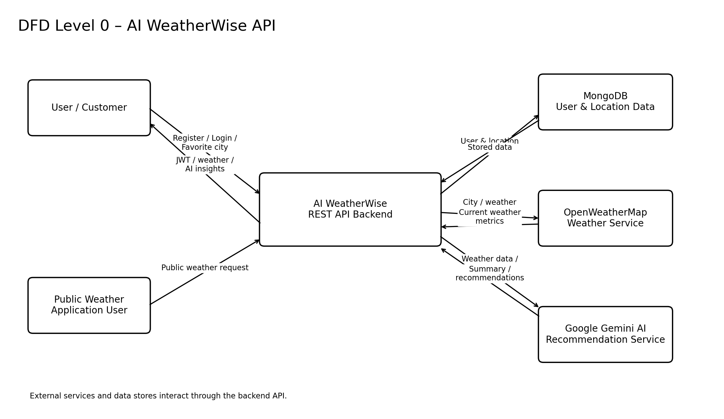
User Stories
The following user stories are derived from the documented WeatherWise usage, user flow, security features, and API functions. Priority and release are marked as not specified where the source documentation does not provide them.
User Type | Functional Requirement  (Epic) | User Story  Number | User Story / Task | Acceptance criteria | Priority | Release
Customer / User | Registration | USN-1 | As a user, I can register for the application using my account credentials. | User account is created and the user can access the application. | Not specified | Not specified
Customer / User | Login | USN-2 | As a user, I can log into the application using my credentials. | The system validates the login and provides authenticated access. | Not specified | Not specified
Customer / User | Favorite Locations | USN-3 | As a user, I can save a city as a favorite location. | The selected city is stored in the user's favorite locations. | Not specified | Not specified
Customer / User | Favorite Locations | USN-4 | As a user, I can manage my favorite cities using CRUD operations. | Favorite locations can be created, viewed, updated, and deleted through the API. | Not specified | Not specified
Customer / User | Weather | USN-5 | As a user, I can fetch current weather metrics for a selected city. | The API returns current weather metrics for the requested city. | Not specified | Not specified
Customer / User | AI Insights | USN-6 | As a user, I can request an AI-generated weather summary. | The system returns a natural-language summary based on current weather conditions. | Not specified | Not specified
Customer / User | AI Recommendations | USN-7 | As a user, I can receive personalized recommendations for activities or clothing based on weather conditions. | The system returns context-aware recommendations generated from the weather data. | Not specified | Not specified
Customer / User | Security | USN-8 | As a user, I can access protected weather and preference features after authentication. | The system validates the JWT before returning protected information. | Not specified | Not specified
Weather Application User | Public Weather | USN-9 | As a public weather application user, I can consume current weather information without creating an account. | Public weather endpoints return current weather metrics without requiring an account. | Not specified | Not specified
Developer / Administrator | API Monitoring | USN-10 | As a developer or administrator, I can monitor API health. | API health can be monitored to verify that the service is functioning. | Not specified | Not specified
Developer / Administrator | User Management | USN-11 | As a developer or administrator, I can manage global user registrations. | The administrator can manage the documented user-registration information. | Not specified | Not specified
Developer / Administrator | Service Integration | USN-12 | As a developer or administrator, I can verify the weather and AI service integrations. | Weather and Gemini AI integrations can be verified for proper operation. | Not specified | Not specified
Customer / User | Resilient Service | USN-13 | As a user, I can use the API even when an external API key is unavailable, where fallback functionality is supported. | The documented fallback mode keeps the API functional when external API keys are unavailable. | Not specified | Not specified

Source note: The first document requires Date, Team ID, Project Name, DFD, and the User Story table. The WeatherWise documentation does not specify a Team ID, priorities, or sprint/release schedule, so these fields are explicitly left as “Not specified” rather than assumed.

